Method for Adapting the SUS and UTAUT-2 for Individuals with Autism, Traumatic Brain Injury and Intellectual Disability
Claude Vincent1,2[0000-0001-5292-4035], Cynthia Henriksen2,3[^{0000-0002-3487-1846]}, Frédéric Dumont2[0000-0002-4372-4741], Chaimaa Zemrani2[0009-0009-5675-3304], Marie-Eve Lamontagne1,2[^{0000-0002-3301-7429]}, Alexandra Lecours2,4[^{0000-0002-4485-7829]} and Ernesto Morales1,2[^{0000-0002-6488-5093]}
¹ Université Laval, School of rehabilitation sciences, Quebec city, Quebec, Canada
² Center of Interdisciplinary Research in Rehabilitation and Social Integration (Cirris), Quebec city, Quebec, Canada
³ Réseau d’évaluation et d’innovation en santé durable (REISD)
⁴ Université du Québec à Trois-Rivières (UQTR), Trois-Rivières, Quebec, Canada
claude.vincent@rea.ulaval.ca
Abstract. The System Usability Scale (SUS) and the Unified Theory of Acceptance and Use of Technology (UTAUT-2) were adapted for a project in which individuals with level 2 autism, light or moderate brain injury, or light intellectual disability were asked to rate the usability and acceptability of a prototype for a computerized workstation training system. The objectives are (1) to detail the five steps of the co-design method and (2) to disseminate adapted versions of the SUS and UTAUT-2 for neuroatypical clients. The co-design method involved to : 1- establish a multidisciplinary advisory group, 2- develop initial drafts of the prototype, 3- conduct think-aloud usability evaluation, 4- test the prototype in clinical simulations and 5- generate a final prototype informed by workshops. The co-design method allowed us to rigorously and efficiently adapt these questionnaires and to validate them in context with the target population. The results from the adapted SUS (78.73 out of 100 = good) led to the pursuit of a computerized training system to facilitate the employability of the target population. The results from the adapted UTAUT-2 are presented for step 3. Steps 4 and 5 will be completed during work activities (assembly of parts) with the training system once manufactured.
Keywords: Usability and acceptance, Pre-employment training system, Autism, brain injury and intellectual disability
- Introduction
The System Usability Scale (SUS) is a single page widely used scale to measure the perceived usability of a system or product, particularly in the field of technology and user interfaces [1]. The SUS contains 10 items, rated on a Likert scale from 1 (strongly disagree) to 5 (strongly agree). Users' answers to these questions are then converted into an overall score between 0 and 100, where a higher score indicates better usability. The advantages of the SUS include its simplicity, speed of administration, and use in a wide range of contexts [2].
The Unified Theory of Acceptance and Use of Technology (UTAUT-2) contains 27 items, rated on a Likert scale from 1 to 7 (completely disagree to neutral to completely agree) including participant information questions [2]. It measures the acceptance of technology considering performance expectancy, effort expectancy, social influence, hedonic motivation, facilitating conditions and behavioral intentions. The UTAUT-2 has been administered to users of banking applications [3], students using software in business school [4], nurses who use computerized medical records [5] and business administrators using resource planning systems [6].
It would be an added-value to use SUS and UTAUT-2 in work rehabilitation, in particular for computerized workstation training systems to increase employability. The SUS and the UTAUT-2 have not been validated among individuals with invisible disabilities such as autism, traumatic brain injury and intellectual disability who use specially developed information technologies such as computerized workstation training systems to increase employability. The objectives are (1) to detail the 5 steps of the co-design method and (2) to disseminate adapted versions of the SUS and UTAUT-2 for individuals with autism level 2, light and moderate brain injury and light intellectual disability.

2. Method

To adapt the questionnaires, the framework for co-design of clinical tools was followed in five steps [7].

2.1 Establish a multidisciplinary advisory group
An evaluator from the Sustainable Healthcare Innovation and Evaluation Network (2nd author), the principal investigator (1st author) and the project coordinator (3rd author) made up the advisory group.

2.2 Develop initial drafts of the prototype (i.e. questionnaire)
In the 1st column of an EXCEL file, the evaluator positioned the original items to be adapted, and in the 2nd column, drafts items according to the readability of the target population, using the reference of the Autistic self advocacy Network [8]. The evaluator sent the EXCEL file to the PI and the coordinator. Individually, they agreed with the proposed adaptation by indicating, “OK” in the third column or proposed a new wording. This step has been done for the SUS and UTAUT-2.

2.3 Conduct think-aloud usability evaluation (i.e. critical appraisal)
The evaluator compiled all draft items in the 3rd column. In a face-to-face discussion, they reached an agreement on a final draft version of the items. The Likert scales presenting the level of agreement has been enhanced with familiar-colored icons as suggested by the Autistic self advocacy Network [8], for examples smiling man in green, neutral man in white, disgruntled man in red). By e-mail, the evaluator forwarded a PowerPoint version of the questionnaire SUS and UTAUT-2, respecting accessibility requirements for the target population, like one idea per line [8]. The PI and the coordinator proposed format changes.

2.4 Test the prototype in clinical simulations
As planned in the initial research project, a researcher (7th author) led clinical simulations, followed by co-design sessions to gather feedback to validate [11] the instructions (training system) and the workstations. After gathering feedback, the same researcher invited everyone present to complete the SUS ‘prototype’. In total, four trainees, three specialized educator and three researchers (1st, 5th and 6th author) filled the SUS. Four trainees were involved in the clinical simulation in three different settings: one with level 2 autism (Workshop ITSA), one with light chronic brain injury (Servio), one with moderate brain injury (Servio) and one with light intellectual disability (Workshop Lapierre). The clinical simulation consisted in trying the training system and the computerized workstation. Workstations were designed to help trainees assemble an electrical resistor, as pre-employment training system (see Fig.1a). The training system provides adapted instructions on a tablet computer with accessible and well identified components to facilitate assembly. Each step appears on a PowerPoint slide (see Fig.1b). There is always a brief written indication, a diagram with arrows and a short video of the action to be taken.

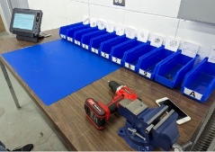
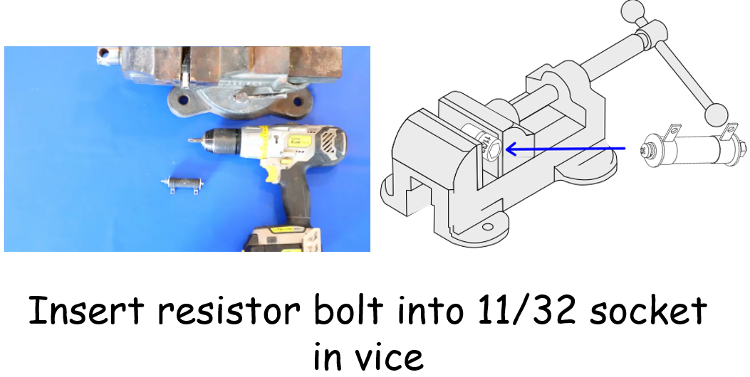

Fig. 1 a. Prototype of the workstation to help trainees assemble an electrical resistor.
b. PowerPoint slide showing one adapted instruction to facilitate assembly.

2.5 Generate a final prototype informed by workshops
A master student (4th author) compiled 12 SUS questionnaires, including comments. To provide a score out of 100 [9], you had to invert the score of the odd-numbered items (1, 3, 5, 7, 9) to be able to add them up because they are formulated in reverse of the even-numbered items (2, 4, 6, 9, 10). Usability scores were from 72.3 to 87.5, with an overall average of 78.73 out of 100. Only one score was in the 'excellent' category (≥ 85.5 out of 100), the others being in the 'good' category (71.4 to 85.4 out of 100) [9]. A TEAMS® workshop was organized with the researchers, the coordinator and the master student to present the results, comments and the final prototype of SUS. See Table 1 for all compilation of the F-SUS.
3. Results
3.1 The 10 modified SUS items
1. I would very much like to use this training system.
2. I find this training system complicated for assembling a resistor.
3. I find this training system easy to use.
4. I need my special educator to use this training system.
5. The instructions and the layout of the equipment at the workstation work well for assembling the parts.
6. There are some confusing elements in this training system.
7. Other people in the shop will quickly learn to assemble parts with this training system.
8. This training system is demanding to use.
9. I'll be able to use the training system without help from anyone.
10. This training system does NOT contain the instructions needed to assemble the parts.

3.2 The modified SUS scale
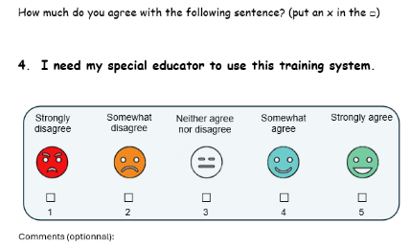
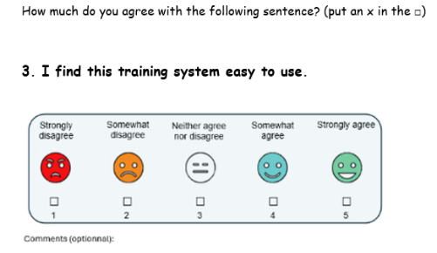
In the SUS, all odd-numbered items must be formulated positively, while all even-numbered items must be formulated in the opposite way. To illustrate this, items 3 and 4 both assess the same variable (ease of use) but are formulated differently (see Fig. 2). The scale remains the same as in the original version, but different-colored face stickers have been added to reflect the degree of agreement. It was requested to have only one idea per page to respect the neuroatypical population [4]. The questionnaire includes 10 pages of questions and must be printed in color.
Fig. 2. Items that assess the same variable but formulated in the opposite way.

3. 3 The 16 modified UTAUT-2 items
Eleven items have been removed from UTAUT-2 [10] as it only assessed acceptance of the training system by users in a research project. Thus, the evaluation was not required for Social influence (items 8, 9, 10), Hedonic motivation (items 15, 16, 17), Financial value (items 18, 19, 20), Habit (item 22) and Behavioral intention (item 25).

The 16 modified items are:
- I find the training system useful for assembling parts the right way.
- I assemble parts faster with the training system.
- The training system enables me to manufacture electrical components quickly and without errors.
- Learning to use the training system is easy for me.
- It's simple and easy for me to understand the training system using the tablet screen.
- I find the training system easy to use.
- I'm getting good at using the training system.
- I have everything I need to use the training system.
- I have received the information I need to use the training system.
- The training system considers the other technologies I use (e.g., tools, bins, pictograms).
- I can get help when I have difficulty using the training system.
- I now use the training system out of habit.
- I use the training system to assemble microelectronic parts.
- I intend to continue using the training system to assemble parts.
- I will always use a training system to remind me of the steps involved in assembling parts.
- I often use instructions for -Prepare the screwdriver and place the jig in the vice. -Insert nuts into screw. -Screw the resistor into the vice

3.4 The modified UTAUT-2 scale

The scale is not the same as in the original version. We've replaced “completely” by “strongly” and we've removed the word “neutral”. The idea is for users to indicate their level of agreement with the training system from 1 to 7. The qualifier “strongly” is preferable because it is more concrete than “completely”. The word “neutral” is removed as it remains abstract to indicate a rating of 4. We have added seven different-colored face stickers to reflect the degree of agreement with numbers 1 to 7, all positioned on an upward slope. This is more accessible for the neuroatypical population [4]. All questions measuring the same dimension are presented on the same page, as requested to have only one idea per page to respect the neuroatypical population [4]. For example, questions 1, 2 and 3 are presented together for the Performance expectancy (see Fig. 3). The questionnaire comprises 7 pages of questions and must be printed in color.

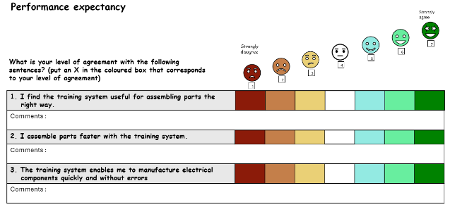
Fig. 3. Items that assess the same concept on one page

4. Discussion
The adapted SUS enabled us to conclude that the usability of the workstation training system was sufficient to proceed with the manufacture of additional workstations and purchase the required tools. The adapted UTAUT-2 will be submitted to steps 4 and 5 of co-design of clinical tools, but after 3 months of using the real computerized workstation training system by the target population.

5. Conclusion/Implications for the AT field
The co-design method allowed us to quickly adapt the SUS and UTAUT-2 while validating them in context among people with autism, traumatic brain injury and intellectual disability. It is planned to use both questionnaires, once the workstations are operational, with special educators and trainees.
Regarding implication of AT fields, we therefore validated 3 different training systems, in terms of instructions and workstations. For example, the instructions for people with intellectual disabilities indicate that users should ask the specialised educator how to prepare the workstation (e.g. adjust the screwdriver, put the jig in the vice). Instructions for people with autism rely more on the direction of the arrows to carry out actions such as where to insert the bolts and the direction to turn (e.g. Fig. 1b). Workstations for people with traumatic brain injury need to take greater account of fatigue, so chairs with armrests, a cane holder and a stool for putting down feet. Whereas for people with autism, workstations need to take more account types of stimulation, such as being able to adjust the color of the light and side panels to reduce visual inputs.

6. References
- Brooke, J. System Usability Scale (SUS). A Retrospective. J. of Usability Studies 8, 29-40 (2013).
- Baumgartner, J, Ruettgers, N, Hasler, A, Sonderegger, A., Sauer, J. Questionnaire experience and the hybrid System Usability Scale: Using a novel concept to evaluate a new instrument, Int J, of Human-Computer Studies 147, 1-11 (2021).
- Venkatesh, V., Thong JYL, Xu, X. Consumer Acceptance and Use of Information Technology: Extending the Unified Theory of Acceptance and Use of Technology, MIS Q 36(1), 157-178 (2012)
- Slade, E., Williams, M., Dwivedi, Y. & Piercy, N. Exploring consumer adoption of proximity mobile payments. Journal of Strategic Marketing 23(3), 209-223 (2015).
- Chauhan, S. & Jaiswal, M. Determinants of acceptance of ERP software training in business schools: Empirical investigation using UTAUT model. Int J. of Management Education 14(3), 248-262 (2016)
- Maillet, É, Mathieu, L. & Sicotte, C. Modeling factors explaining the acceptance, actual use and satisfaction of nurses using an Electronic Patient Record in acute care settings: An extension of the UTAUT. Int J. of Medical Informatics 84(1), 36-47 (2015).
- Keong, M., Ramayah, T., Kurnia, S. &, Lo, M.C. Explaining intention to use an enterprise resource planning system: an extension of the UTAUT. Business Strategy Series 13(4), 173-180 (2012).
- Woodward, M., Dixon-Woods, M. … How to co-design a prototype of a clinical practice tool: a framework with practical guidance and a case study. BMJ Quality & Safety 33, 258-270 (2024).
- Autistic self advocacy Network. One Idea Per Line: A Guide to Making Easy Read Resources. 65pp. https://autisticadvocacy.org/wp-content/uploads/2021/07/One-Idea-Per-Line.pdf
- Gronier, G., & Baudet, A. Psychometric evaluation of the F-SUS: Creation and validation of the French version of the SUS. Int J. of Human-Computer Interaction 37(16), 1571-82 (2021).
- Pagé, I., Roos, M., ... Lamontagne, M.E., Massé-Alarie, H., & Blanchette, A. UTAUT2-based questionnaire: cross-cultural adaptation to Canadian French. Disab & Rehab 45(4), 709–716 (2022).
- Morales E, Rousseau J, Passini R. Using a Co-Design Methodology for Research on Environmental Gerontology. J Gerontol Geriat Res 1(3), 100-106 (2012).

Funding and ethic statements
The research project was funded by the Ministry of Economy, Innovation and Energy (2022-2027-PSOv2a-UL-IS-63676). The project was approved by the CIUSSS-CN Research and Ethics Committee (#2022-2378).

Table 1. Compilation of the French- System Usability Scale (F-SUS) [9], adapted for neuroatypical populations, carried out with 10 participants in three settings following the use of a training system to assemble an electric resistor

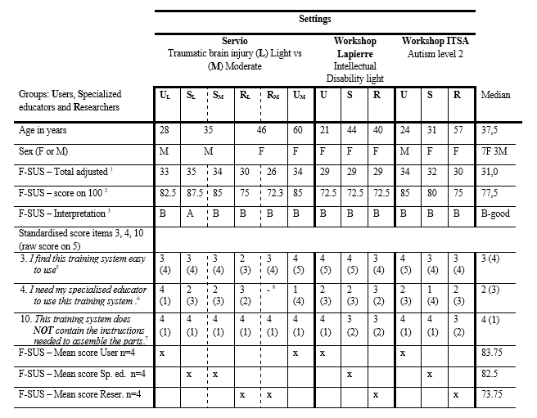
Note 1. Total adjusted score= SUS 1-N+SUS 2-N+SUS 3-N+SUS 4-N+…+SUS 10-N
Note 2. Score SUS on 100= Total adjusted score ×2.5
Note 3. 85.5 – 90: Excellent (A); 71.4 – 85: Good (B); 50.9 – 71: Okay (C); >50: Poor (D)
Note 4. 1= Strongly disagree, 2= Somewhat disagree, 3= Neither agree or disagree, 4= Somewhat agree, 5= Totally disagree
Note 5. Odd-numbered items (1, 3, 5, 7, 9) are weighted to obtain a score out of 100: SUS “X”-N = SUS “X” Raw - 1
Note 6. Even-numbered items (2, 4, 6, 9, 10) are weighted to obtain a score out of 100: SUS “X”-N = 5 −SUS “X” Raw
Note 7. Item 10 was modified with a negative formulation to go in the same direction as the original SUS, when the item is even.
Note 8. This participant marked Not applicable, for item 4. The raw score was therefore calculated on 9 items instead of 10.

